**Assignment 7 of INF552**

**Yiming Liu & Yi Ren**

**Part 1:**

1. Language: Python 2.7
2. Data structure: (1). Array: grid, noisy_distance, result_grid, domain, pai(start_probability), path (2). Matrix: A (transition probability), B (pseudo emission probability), (3). Dictionary: dict_index_point, dict_point_index
3. Logic: (1). Get the initial probability matrix: pai. (2). Using domain and grid, make transition probability matrix. (3). Make emission probability matrix. (4). Use Viterbi algorithm to compute the most likely trajectory.
4. Result (“9” means the position that the robot walk though):

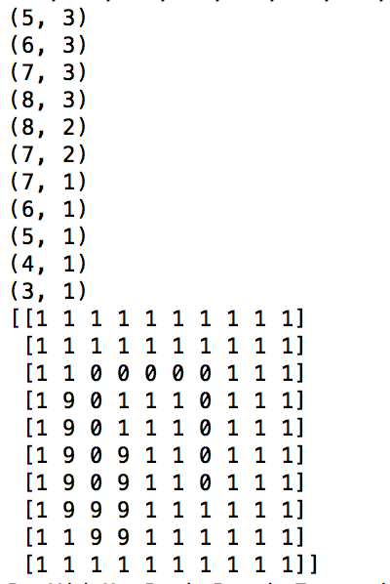

The trajectory is (5, 3)->(6, 3)->(7, 3)->(8, 3)->(8, 2)->(7, 2)->(7, 1)->(6, 1)->(5, 1)->(4, 1)->(3, 1)

**Part 2:**

On the Internet, I find a script [1] that using Viterbi algorithm in HMM. And here is the result:

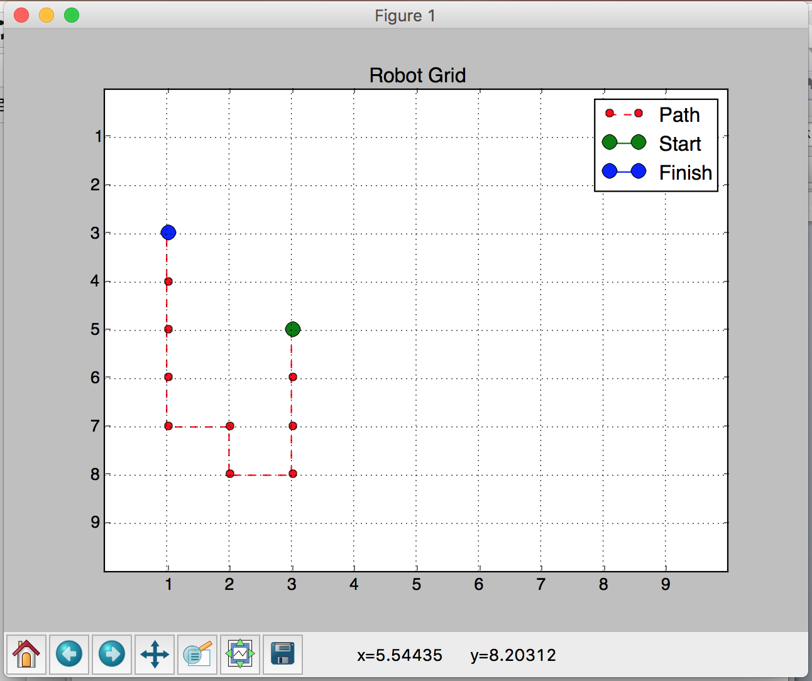

When I read this script, I am surprise that it is so complex. I think this script is not good for extension because there are some hard codes in the script.

**Part 3:**

An interesting application is that HMM is used in Speech recognition. What speech recognition doing is translate sound from human to text. Each HMM models a diphone or phoneme in context. Observations are speech features, e.g., pitch, energy, prosodic features, etc. [2]

Division of Work:

Both members are discuss the algorithm, write the coding, verifying the correctness and write the report of the homework.

Reference:

[1]. Github, diwz / Machine-Learning-Algorithms/HiddenMarkovModel.py.

[2]. HMM-based Speech Synthesis System, <http://hts.sp.nitech.ac.jp/>